## ViewChildren & ContentChildren

**Learning Objectives**

* Understand the difference between view children and content children of a component.
* Know how to get references to child components in host components.

**Example application**

The view children of a given component are the elements used *within* its template, its view.

We can get a reference to these view children in our component class by using the @ViewChild decorator.

We’ll explain how all this works using the joke application we’ve been working with so far in this course.

We’ve changed the application so that the JokeListComponent shows two jokes in it’s own view and one joke which is content projected from it’s host AppComponent, like so:

*JokeListComponent*

@Component({

selector: 'joke-list',

template: `

<

h4>View Jokes</h

4>

<

joke *ngFor="let j of jokes" [joke]="j">

①

<span class="setup">{{ j.setup }}?</span>

<h1 class="punchline">{{ j.punchline }}</h1>

<

/joke

>

<

h4>Content Jokes</h

4>

ng-content></ng-content>

<

②

`

})

class JokeListComponent {

jokes: Joke[] = [

new Joke("What did the cheese say when it looked in the mirror", "Hello-me

(

Halloumi)"),

new Joke("What kind of cheese do you use to disguise a small horse", "Mask-a-pony

(

Mascarpone)"

)

];

}

1. The component renders jokes in it’s *own* view.
2. It also projects some content from it’s host component, in our example the other content is going

to be a third joke.

*AppComponent*

@Component({

selector: 'app',

template: `

<

joke-list

>

<joke [joke]="joke">

①

<span class="setup">{{ joke.setup }}?</span>

<h1 class="punchline">{{ joke.punchline }}</h1>

</joke>

<

/joke-list

>

`

})

class AppComponent {

joke: Joke = new Joke("A kid threw a lump of cheddar at me", "I thought

‘

That

’

s not

very mature

’

");

}

① Use content projection to inject a third joke into the JokeListComponent.

When we view this app now we see 3 jokes, two of which are from the JokeListComponent and the third is projected in from the AppComponent.

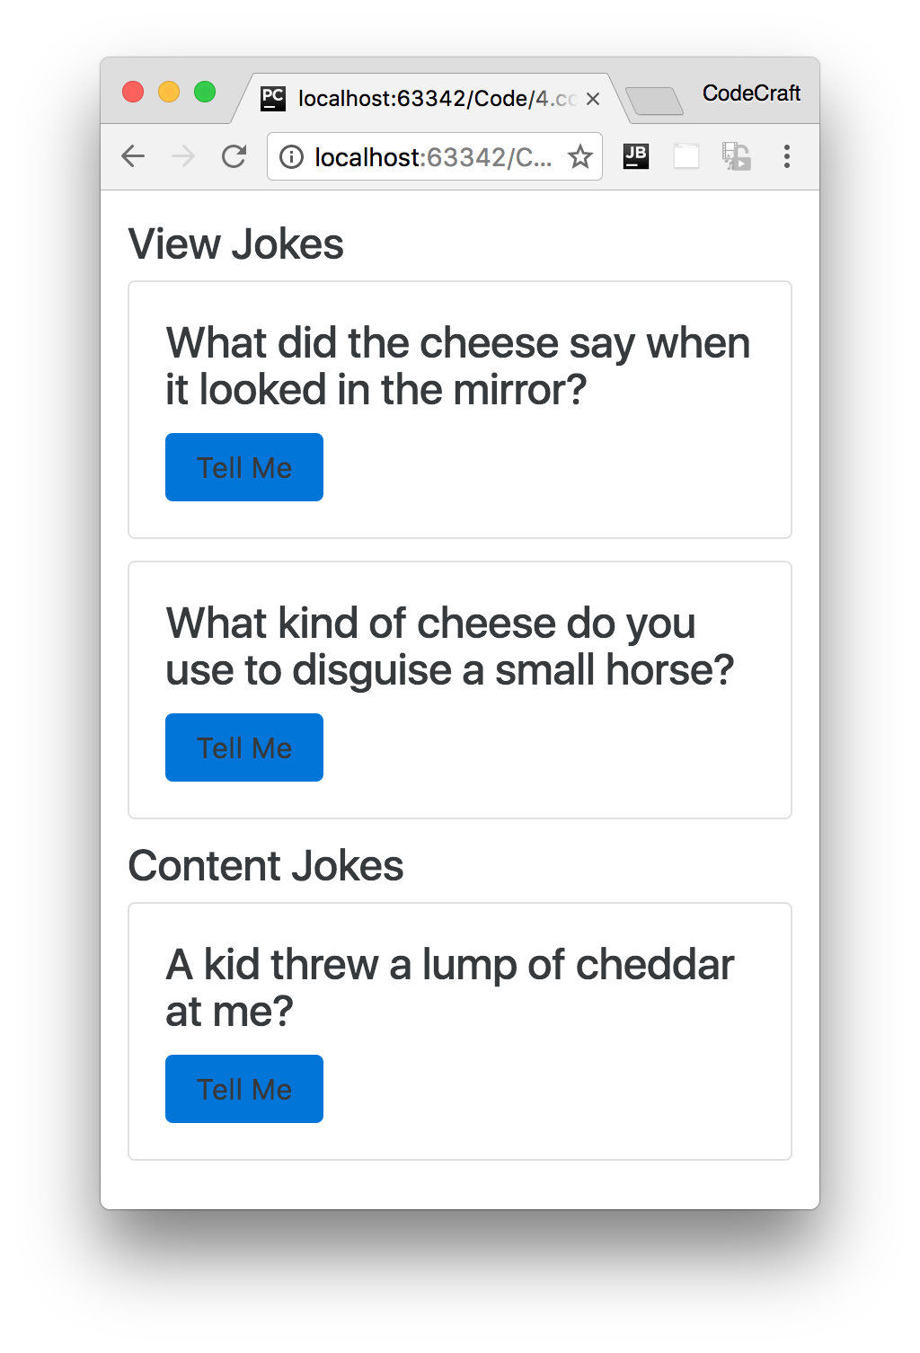

**ViewChild**

In our JokeListComponent lets add a reference to the child JokeComponents that exists in it’s view.

We do this by using the @ViewChild decorator like so:

import { ViewChild } from '@angular/core';

.

.

.

@Component({

selector: 'joke-list',

template: `

<

h4 #header>View Jokes</h

4>

<

joke *ngFor="let j of jokes" [joke]="j"

>

<span class="setup">{{ j.setup }}?</span>

<h1 class="punchline">{{ j.punchline }}</h1>

<

/joke

>

<

h4>Content Jokes</h

4>

<

ng-content></ng-content

>

`

})

class JokeListComponent {

jokes: Joke[] = [

new Joke("What did the cheese say when it looked in the mirror", "Hello-me

(

Halloumi)"),

new Joke("What kind of cheese do you use to disguise a small horse", "Mask-a-pony

(

Mascarpone)"

)

];

@ViewChild(JokeComponent) jokeViewChild: JokeComponent;

①

constructor() {

console.log(`new - jokeViewChild is ${this.jokeViewChild}`);

}

}

① We are storing a reference to the child JokeComponent in a property called jokeViewChild.

jokeViewChild isn’t an instance of a Joke class, it is the actual instance of the child JokeComponent that exists inside *this* components view.

We create a new property called jokeViewChild and we pre-pend this with a decorator of @ViewChild. This decorator tells Angular *how* to find the child component that we want to bind to this property.

A @ViewChild decorator means, search inside this components template, it’s view, for this child component.

The parameter we pass as the first argument to @ViewChild is the *type* of the component we want to search for, if it finds more than one it will just give us the first one it finds.

If we try to print out the reference in the constructor, like the code sample above, undefined will be printed out.

That’s because by the time the constructor is called we haven’t rendered the children yet. We render in a *tree down approach* so when a parent component is getting constructed it means the children are not yet created.

We can however hook into the lifecycle of the component at the point the view children have been created and that’s with the ngAfterViewInit hook.

To use this we need to make our component implement the interface AfterViewInit.

@Component({

selector: 'joke-list',

template: `

<

h4 #header>View Jokes</h

4>

<

joke *ngFor="let j of jokes" [joke]="j"

>

<span class="setup">{{ j.setup }}?</span>

<h1 class="punchline">{{ j.punchline }}</h1>

>

<

/joke

<

h4>Content Jokes</h

4>

ng-content></ng-content

>

<

`

})

class JokeListComponent implements AfterViewInit {

jokes: Joke[] = [

new Joke("What did the cheese say when it looked in the mirror", "Hello-me

(

Halloumi)"),

new Joke("What kind of cheese do you use to disguise a small horse", "Mask-a-pony

(

Mascarpone)"

)

];

@ViewChild(JokeComponent) jokeViewChild: JokeComponent;

constructor() {

console.log(`new - jokeViewChild is ${this.jokeViewChild}`);

}

ngAfterViewInit() {

console.log(`ngAfterViewInit - jokeViewChild is ${this.jokeViewChild}`);

}

}

In the ngAfterViewInit function jokeViewChild has been initialised and we can see it logged in the console.

**ViewChildren**

The above isn’t so useful in our case since we have *multiple* joke children components. We can solve that by using the alternative @ViewChildren decorator along side the QueryList generic type.

import { ViewChildren, QueryList } from '@angular/core'; .

. . class JokeListComponent implements AfterViewInit {

jokes: Joke[] = [

new Joke("What did the cheese say when it looked in the mirror", "Hello-me

(Halloumi)"),

new Joke("What kind of cheese do you use to disguise a small horse", "Mask-a-pony

(Mascarpone)")

];

@ViewChild(JokeComponent) jokeViewChild: JokeComponent;

@ViewChildren(JokeComponent) jokeViewChildren: QueryList<JokeComponent>; ①

ngAfterViewInit() {

console.log(`ngAfterViewInit - jokeViewChild is ${this.jokeViewChild}`);

let jokes: JokeComponent[] = this.jokeViewChildren.toArray(); ②

console.log(jokes);

}

}

1. We use the @ViewChildren decorator which matches *all* JokeComponent`s and stores them in a `QueryList called jokeViewChildren.
2. We can convert our QueryList of JokeComponent`s into an array by calling `toArray()

When we run the above application we see two JokeComponents printed to the console, like so:

Array[2]

>

0: JokeComponent

>

1: JokeComponent



The reason we see 2 jokes printed out and 3 is because only two of the jokes are

*view children*

the other joke is a

*content child*

. We cover content children in the end

of ths lecture.

**ViewChild referencing a template local variable**

One practical application of @ViewChild is to get access to template local variables in our component class.

In the past we’ve said that template local variables are just that, *local* to the template.

But as the first param to the @ViewChild decorator we can also pass the name of a template local variable and have Angular store a reference to that variable on our component, like so:

@Component({

selector: 'joke-list',

template: `

<h4 #header>View Jokes</h4>

<joke *ngFor="let j of jokes" [joke]="j">

<span class="setup">{{ j.setup }}?</span>

<h1 class="punchline">{{ j.punchline }}</h1>

</joke>

<h4>Content Jokes</h4>

<ng-content></ng-content>

`

})

class JokeListComponent implements AfterViewInit {

jokes: Joke[] = [

new Joke("What did the cheese say when it looked in the mirror", "Hello-me

(Halloumi)"),

new Joke("What kind of cheese do you use to disguise a small horse", "Mask-a-pony

(Mascarpone)")

];

@ViewChild(JokeComponent) jokeViewChild: JokeComponent;

@ViewChildren(JokeComponent) jokeViewChildren: QueryList<JokeComponent>; @ViewChild("header") headerEl: ElementRef; ①

ngAfterViewInit() {

console.log(`ngAfterViewInit - jokeViewChild is ${this.jokeViewChild}`);

let jokes: JokeComponent[] = this.jokeViewChildren.toArray();

console.log(jokes);

console.log(`ngAfterViewInit - headerEl is ${this.headerEl}`);

//noinspection TypeScriptUnresolvedVariable

this.headerEl.nativeElement.textContent = "Best Joke Machine"; ②

}

}

1. The type of our template variable is an ElementRef, which is a low level reference to any element in the DOM. We are requesting a reference to the header template variable which points to the first <h4> element in the template.
2. Since headerEl is an ElementRef we can interact with the DOM directly and change the title of our header to *Best Joke Machine*.

 It’s not recommended to interact with the DOM directly with an that results in code that’s not very portable. ElementRef since

**ContentChild & ContentChildren**

The concept of a *content child* is similar to that of a *view child* but the content children of the given component are the child elements that are *projected* into the component from the host component.

In our example application we are projecting one joke in from the host AppComponent.

To get a reference to that child we can use either the @ContentChild or the @ContentChildren decorators. They work in similar ways to the view child counterparts, @ContentChild returns one child and @ContentChildren returns a QueryList.

Lets use @ContentChild to get a reference to the third joke that is projected in, like so:

import { ContentChildren, ContentChild } from '@angular/core'; .

. . class JokeListComponent implements AfterContentInit, AfterViewInit { ①

jokes: Joke[] = [

new Joke("What did the cheese say when it looked in the mirror", "Hello-me

(Halloumi)"),

new Joke("What kind of cheese do you use to disguise a small horse", "Mask-a-pony

(Mascarpone)")

];

@ViewChild(JokeComponent) jokeViewChild: JokeComponent;

@ViewChildren(JokeComponent) jokeViewChildren: QueryList<JokeComponent>;

@ViewChild("header") headerEl: ElementRef;

@ContentChild(JokeComponent) jokeContentChild: JokeComponent; ②

ngAfterContentInit() { ③

console.log(`ngAfterContentInit - jokeContentChild is ${this.jokeContentChild}`);

}

ngAfterViewInit() {

console.log(`ngAfterViewInit - jokeViewChild is ${this.jokeViewChild}`);

let jokes: JokeComponent[] = this.jokeViewChildren.toArray();

console.log(jokes);

console.log(`ngAfterViewInit - headerEl is ${this.headerEl}`);

this.headerEl.nativeElement.textContent = "Best Joke Machine";

}

}

1. Just like before we need to tap into one of the component lifecycle hooks, this time it’s AfterContentInit
2. We create a jokeContentChild property and bind it to the content child by using the @ContentChild

decorator.

1. By the time the ngAfterContentInit hook is run the jokeContentChild property is set to the content child.

 You can implement multiple interfaces just by separating them with a ,.

If we logged jokeContentChild in our constructor it would again log undefined, since it’s not actually initialised at that point.

Content children are only visible by the time the AfterContentInit lifecycle hook has run.

**Summary**

An Angular application is composed from a number of components nested together.

These components can nest in two ways, as view children, in the template for that component. Or they can nest as content children, via content projection from a host component.

As developers of our components we can get access to these child components via the @ViewChild and @ContentChild (and @ViewChildren and @ContentChildren) decorators.

View children of a component are the components and elements in *this* components view.

Content children of a component are the components and elements that are *projected* into *this* components view by a host component.

View children are only initialised by the time the AfterViewInit lifecycle phase has been run.

Content children are only initialised by the time the AfterContentInit lifecycle phase has been run.

**Listing**

<http://plnkr.co/edit/V6tqGnvNiiOOMMLmajKP?p=preview>

*script.ts*

import {platformBrowserDynamic} from '@angular/platform-browser-dynamic';

import {

Component,

NgModule,

Input,

Output,

EventEmitter,

ViewEncapsulation,

SimpleChanges,

OnChanges,

OnInit,

DoCheck,

AfterContentInit,

AfterContentChecked,

AfterViewInit,

AfterViewChecked,

OnDestroy,

ViewChild,

ViewChildren,

ContentChild,

ContentChildren,

ElementRef,

QueryList

}

from '@angular/core';

import {BrowserModule} from '@angular/platform-browser';

class Joke {

public setup: string;

public punchline: string;

public hide: boolean;

constructor(setup: string, punchline: string) {

this.setup = setup;

this.punchline = punchline;

this.hide = true;

}

toggle() {

this.hide = !this.hide;

}

}

@Component({

selector: 'joke',

template: `

<

div class="card card-block"

>

<h4 class="card-title">

<ng-content select=".setup"></ng-content>

</h4>

<p class="card-text"

[hidden]="data.hide">

<ng-content select=".punchline"></ng-content>

</p>

<a class="btn btn-primary"

(click)="data.toggle()">Tell Me

</a>

<

/div

>

`

})

class JokeComponent {

@Input('joke') data: Joke;

}

@Component({

selector: 'joke-list',

template: `

<h4 #header>View Jokes</h4>

<joke *ngFor="let j of jokes" [joke]="j">

<span class="setup">{{ j.setup }}?</span>

<h1 class="punchline">{{ j.punchline }}</h1>

</joke>

<h4>Content Jokes</h4>

<ng-content></ng-content>

`

})

class JokeListComponent implements OnInit,

AfterContentInit,

AfterViewInit {

jokes: Joke[] = [

new Joke("What did the cheese say when it looked in the mirror", "Hello-me

(Halloumi)"),

new Joke("What kind of cheese do you use to disguise a small horse", "Mask-a-pony

(Mascarpone)")

];

@ViewChild(JokeComponent) jokeViewChild: JokeComponent;

@ViewChildren(JokeComponent) jokeViewChildren: QueryList<JokeComponent>;

@ViewChild("header") headerEl: ElementRef;

@ContentChild(JokeComponent) jokeContentChild: JokeComponent;

constructor() {

console.log(`new - jokeViewChild is ${this.jokeViewChild}`);

console.log(`new - jokeContentChild is ${this.jokeContentChild}`);

}

ngAfterContentInit() {

console.log(`ngAfterContentInit - jokeContentChild is ${this.jokeContentChild}`);

}

ngAfterViewInit() {

console.log(`ngAfterViewInit - jokeViewChild is ${this.jokeViewChild}`);

let jokes: JokeComponent[] = this.jokeViewChildren.toArray();

console.log(jokes);

console.log(`ngAfterViewInit - headerEl is ${this.headerEl}`);

this.headerEl.nativeElement.textContent = "Best Joke Machine";

}

}

@Component({

selector: 'app',

template: `

<

joke-list

>

<joke [joke]="joke">

<span class="setup">{{ joke.setup }}?</span>

<h1 class="punchline">{{ joke.punchline }}</h1>

</joke>

<

/joke-list

>

`

})

class AppComponent {

joke: Joke = new Joke("A kid threw a lump of cheddar at me", "I thought

‘

That

’

s not

very mature

’

");

}

@NgModule({

imports: [BrowserModule],

declarations: [

AppComponent,

JokeComponent,

JokeListComponent

],

bootstrap: [AppComponent]

})

export class AppModule {

}

platformBrowserDynamic().bootstrapModule(AppModule);

## Wrapping Up

In this section we covered Components in much more detail than the quickstart.

We discussed how to architect your application using components in Angular. We explained one method of breaking down your applications design into components with clear responsibilities, inputs and outputs.

We covered some of of the ways we can configure a component via the @Component decorator, specifically the templateUrl, styles, styleUrls and encapsulation configuration properties.

We covered the mechanism of content projection in Angular with the ng-content tag.

We explained the various component lifecycle phases, when they are run and how to hook into them with functions on the component.

Finally we covered the idea of view and content children and how to get references to each in a component.

## Activity

Create a set of components with work together to create a *Carousel* which we can use to display different images in rotation.

We also want the carousel delay between rotations to be configurable.

The markup for our carousel will look like so:

<

carousel [delay]="2000"

>

<carousel-item>

<img src="https://unsplash.it/200?image=0" alt="">

</carousel-item>

<carousel-item>

<img src="https://unsplash.it/200?image=100" alt="">

</carousel-item>

<carousel-item>

<img src="https://unsplash.it/200?image=200" alt="">

</carousel-item>

<

/carousel

>

**Steps**

Fork this plunker:

<http://plnkr.co/edit/oajylErBv8adMGXywNTC?p=preview>Finish off the components to implement the carousel.

Read any **TODO** comments in the plunker for hints.

**Solution**

When you are ready compare your answer to the solution in this plunker: